Workshop Bodenburg
Stage Lighting
Headed by:
Kai Piippo
Participants:
Julia Steinhoff
Sabine Schumann
Bruno Demeester
Anthony Tischhauser
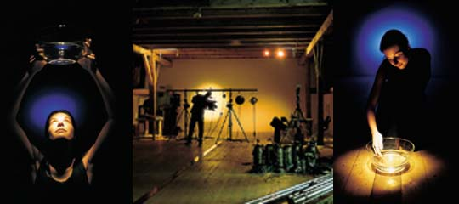
Kai Piippo wanted the participants in his group to learn to see in a new way, and to do this by playing with light in a totally dark space. This is, in effect, playing with human perception on a very basic level. Back to the roots so to speak.
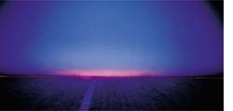
"I have often tried to establish the actual moment of creation of an idea. Exactly when do I get an idea and what factors were involved?" explains Kai, who now works predominantly in the field of architectural lighting, but has a wealth of experience in theatre and stage lighting. "One thing is for sure, you must be totally absorbed and focussed on the task, and be in flow with the whole setting if you want to reach the peak of your capability", he adds.
The first task in the group was therefore to create an atmosphere without practical problems that might disturb "the flow". The group was provided with theatre lighting equipment to work with. The first workshop exercise was to create a sunrise on a white wall. This was not easy, since every participant had his/her own memory of what they perceive. It took the group two and a half hours to cre-ate a three-minute show.
The second exercise was to use light to create Heaven and hell. For this, the group built a set with aluminium foil on the floor and black canvas at the sides. One of the participants volunteered to be the model. The group's idea was to show the change in mood using light with a person on the set. The model sat on the floor completely still. Only the light changed: from Heavenly white and blue to glowing orange and red. These two exercises showed the group that light can be used effectively to manipulate feelings and create visual performances.
For the presentation to visitors on the final night the group decided to create a performance with light, music and one actor. The resulting five-minute performance ran 21 times on the final evening.
Kai Piippo was pleased with the results of his group "One thing that you can learn from a workshop of this kind is that the first idea you have improves after testing. If you continue improving the idea to the fourth or fifth generation of ideas, you will get the best possible result. This way of working is possible in the theatre, but very seldom in architectural projects. In general, I would say that architectural lighting and theatre lighting are moving closer together. You only have to look at the developments in lighting control, the use of colour, luminaire design and lighting design concepts. But it is very important for workshop participants to understand that you require many years' experience in all these aspects of lighting design before you can be regarded a professional. Only then can you exploit the advantages of theatre lighting and architectural lighting effectively to create the desired result".

